Subiaco Marist Cricket Club

PO Box 2173, Churchlands
Western Australia 6018

https://www.subiacomaristcc.com.au/

ABN: 92 857 970 674

Subiaco Marist Cricket Club

Club Insights and Partnership Opportunity 2025/26 (information sourced from PlayerHQ and ClubStats)

Building Community Through Cricket
Located in Churchlands, Western Australia, Subiaco Marist Cricket Club (SMCC) is one of Perth’s most vibrant and rapidly growing community cricket clubs. Our home grounds are situated at John Lucas Oval at Newman College, where generations of players, families and supporters gather to play, learn and celebrate the game of cricket.
For nearly four decades, our club has been dedicated to developing players, strengthening community ties, and providing pathways for people of all ages to participate in cricket.
Today, SMCC is recognised as one of the largest clubs competing in the Western Australian Suburban Turf Cricket Association (WASTCA), fielding multiple senior teams across competitive and social grades.

Our History
The foundations of Subiaco Marist Cricket Club trace back to the Marist Newman Old Boys, whose first season began in 1987/88.
In the 1999/2000 season, the club merged with the Subiaco Women’s Cricket Club, forming the organisation we know today as Subiaco Marist Cricket Club.
This merger brought together strong cricket traditions and helped establish a club built on the values of:
- Spirit
- Mateship
- Character
- Commitment
These values continue to guide the club today as we develop players and build a supportive sporting community.

Our Club Today
Subiaco Marist Cricket Club is now one of Perth’s most active community cricket organisations, offering opportunities for players from 5 years old through to senior competition.

Participation Levels
Our programs include:
Cricket Blast (Ages 5–8)
- Entry-level program introducing young children to cricket
- Runs on Friday evenings
- Over 140 participants in recent seasons
Junior Cricket (Ages 9–17)
- Boys and girls teams competing in the Metropolitan Junior Community Cricket competition
- Structured development pathway aligned with Cricket Australia programs

Senior Cricket
- Multiple senior teams competing in WASTCA
- Two-day, one-day and T20 formats
- Competitive and social grades to suit players of all abilities
Across all programs, SMCC continues to grow each season as more families choose cricket as their community sport.
Vets Cricket
- Over 50’s competition
- T20 formats
- Competitive and social grades to suit players of all abilities

Our Facilities
Subiaco Marist Cricket Club is proudly based at:

John Lucas Oval
Newman College, Churchlands WA
Facilities include:
- Turf cricket wickets
- Astro cricket ground
- Junior development areas
- Training facilities
- Community gathering spaces
Being located within the Newman College sporting precinct provides a unique environment where school, community and club sport come together.
We also play on Luketina, Sheldrake, Woodlands, Kapinara Primary, Webley Downs Primary, McLean Park

Our Community Impact
Cricket clubs play a unique role in building local community.
At SMCC we provide:

Youth Development
Our programs help young players develop:
- Confidence
- Teamwork
- Leadership
- Discipline
- Healthy lifestyles

Family Engagement
Cricket is one of the few sports where families participate together across generations. Many of our senior players began as juniors within the club.

Volunteer Network
The club is supported by a dedicated group of:
- Volunteer coaches
- Parents
- Administrators
- Community supporters
Their contribution ensures SMCC remains a thriving community organisation.

The Churchlands District Cricket Hub
Subiaco Marist Cricket Club is proudly based at John Lucas Oval at Newman College, placing the club at the centre of the Churchlands district sporting community.
Participation data shows the majority of players come from nearby suburbs including:
- Churchlands
- Woodlands
- Doubleview
- Scarborough
- Wembley Downs
- Floreat
- City Beach
- Karrinyup
This strong geographic concentration confirms the club’s role as the primary cricket hub for families in the Churchlands district.

Participation Growth

Registrations by Season
Season | Registrations
2023/24 | 450
2024/25 | 495
2025/26 | 601
This represents 34% growth over three seasons, highlighting the increasing popularity of the club and its programs.

Player Development Pathway
SMCC provides a clear pathway for cricketers:
Cricket Blast → Junior Competition → Colts → Senior Grades → Veterans Cricket
Participation data confirms the success of this pathway.

Blasters → Junior Cricket
- 303 Cricket Blast participants
- 30 progressed into junior competition
Conversion rate: 9.9%

Junior → Senior Cricket
Season | Juniors Playing Seniors
2023/24 | 4
2024/25 | 12
2025/26 | 14
This represents a 250% increase in juniors playing senior cricket.

Seniors Developed Through SMCC Juniors
- 303 senior players
- 32 previously played SMCC juniors
10.6% confirmed internal development pathway

SMCC Player Development Success
Subiaco Marist Cricket Club provides a strong development pathway for players progressing through community cricket and into higher levels of the game.
Participation and player movement data across the past three seasons demonstrates the club’s success in developing players capable of progressing into both senior community cricket and Western Australia’s district cricket pathway.

Player Pathway Progression
Over the past three seasons Subiaco Marist Cricket Club has produced:
Pathway Category | Players
Juniors Playing Senior Cricket (same season) | 30
Players Progressing to District Cricket Clubs | 11
Players Selected for District Season Permits | 1
Total Advanced Pathway Players | 42
These figures demonstrate the club’s ability to successfully develop players who progress beyond junior cricket into more advanced levels of the game.

District Cricket Pathway
SMCC players have progressed into several WA Premier (District) Cricket clubs, which represent the highest level of club cricket in Western Australia.
District clubs receiving SMCC players include:
- Claremont Nedlands Cricket Club
- Scarborough Cricket Club
- Joondalup District Cricket Club
These clubs compete in WA Premier Cricket, the primary pathway to state and national representation.

District Season Permits
In some cases, talented SMCC players are granted season permits, allowing them to represent both their district club and Subiaco Marist during the same season.
This arrangement allows players to experience district-level competition while continuing to play community cricket with their local club.

Strengthening the Future of Cricket
The number of SMCC juniors playing senior cricket has increased significantly:
Season | Juniors Playing Senior Cricket
2023/24 | 4
2024/25 | 12
2025/26 | 14
This represents a 250% increase in junior players progressing into senior cricket over three seasons, highlighting the club’s strengthening development system.

A Complete Cricket Pathway
Subiaco Marist Cricket Club provides opportunities for players at every stage of the game:
Cricket Blast → Junior Competition → Junior Players in Senior Teams → District Cricket Pathways → Premier Cricket
This pathway allows players to develop their skills, remain connected to the sport, and pursue higher levels of competition while continuing to represent their community club.
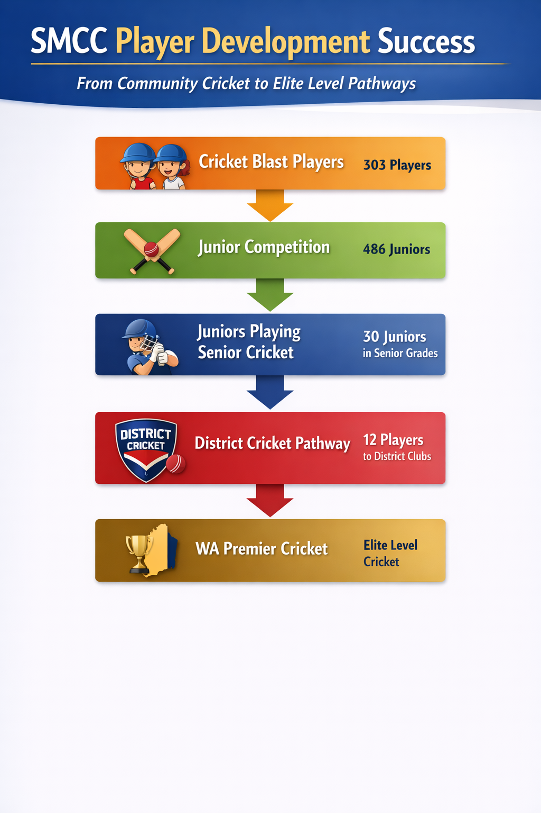

School Community
Subiaco Marist Cricket Club has strong participation from schools within the Churchlands district.

Top Schools
School | Players
Newman College | 234
Holy Rosary | 39
Churchlands SHS | 25
Trinity College | 23
Hale School | 20
This highlights the strong connection between the club and local schools.

Geographic Reach
Player postcode data shows strong participation from:
- Churchlands (6018)
- Scarborough (6019)
- Floreat (6014)
These areas form the core catchment of the club.

Community Impact
The club plays an important role in the local community.
Each season the club engages with:
- 600+ players
- 1,200–1,500 family members
- 100+ volunteers
Total community reach:
Over 2,000 people

Our Vision for the Future
Subiaco Marist Cricket Club is committed to becoming the leading community cricket club in Perth’s western suburbs.
Our strategic priorities include:
- Expanding junior participation?
- Developing stronger coaching programs?
- Enhancing training and playing facilities?
- Creating clear player pathways?
- Strengthening our club culture and community engagement?
We are building a club that offers elite opportunities while maintaining strong community values.

Partnership & Sponsorship Opportunities
Community sport relies on strong partnerships with businesses and supporters.
By partnering with Subiaco Marist Cricket Club, sponsors gain:

Brand Exposure
- Club apparel and uniforms
- Ground signage
- Social media exposure
- Website promotion
- Event sponsorship

Community Engagement
Sponsors become part of a trusted local organisation with strong ties to families and schools.

Networking Opportunities
Our club events provide opportunities to connect with local business owners, parents and professionals.

Positive Brand Alignment
Associating with youth development, community sport and healthy lifestyles enhances corporate reputation.

Why Partner With Us?
Subiaco Marist Cricket Club offers sponsors access to:
- Hundreds of players and families
- Growing junior participation
- Large senior competition presence
- Strong social media engagement
- High community visibility in Perth’s western suburbs
Your support directly helps:
- Provide equipment for junior players
- Improve training facilities
- Support volunteer coaches
- Grow participation in cricket

Join the Subiaco Marist Cricket Community
Whether you are a player, parent, volunteer or sponsor, Subiaco Marist Cricket Club welcomes you to be part of our journey.
Together we are building a club where cricket, community and character thrive.

Graphs and Statistics

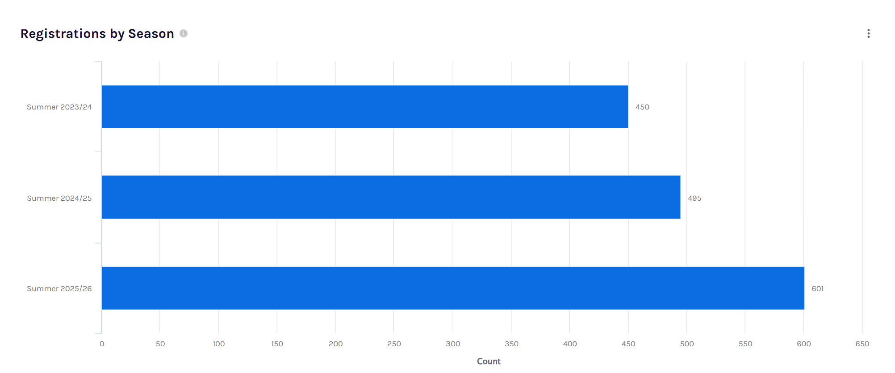

Registrations by Season – Participation Growth
This chart shows strong and consistent growth in total player registrations across the past three seasons at Subiaco Marist Cricket Club.
- Summer 2023/24: 450 registrations
- Summer 2024/25: 495 registrations
- Summer 2025/26: 601 registrations
The data highlights an overall increase of 151 players over three seasons, representing approximately 34% growth since 2023/24.
The most significant increase occurred between 2024/25 and 2025/26, where registrations rose by 106 players, indicating a substantial expansion in participation across the club’s programs.
This growth reflects the club’s increasing popularity within the community, successful recruitment and retention of players, and the strength of its junior development and senior participation pathways. The upward trend also demonstrates the club’s capacity to support a growing player base and reinforces its position as a leading community cricket club in Perth’s western suburbs.
For sponsors and partners, this continued growth highlights the club’s expanding reach, strong community engagement, and increasing exposure opportunities through a rapidly growing membership base.
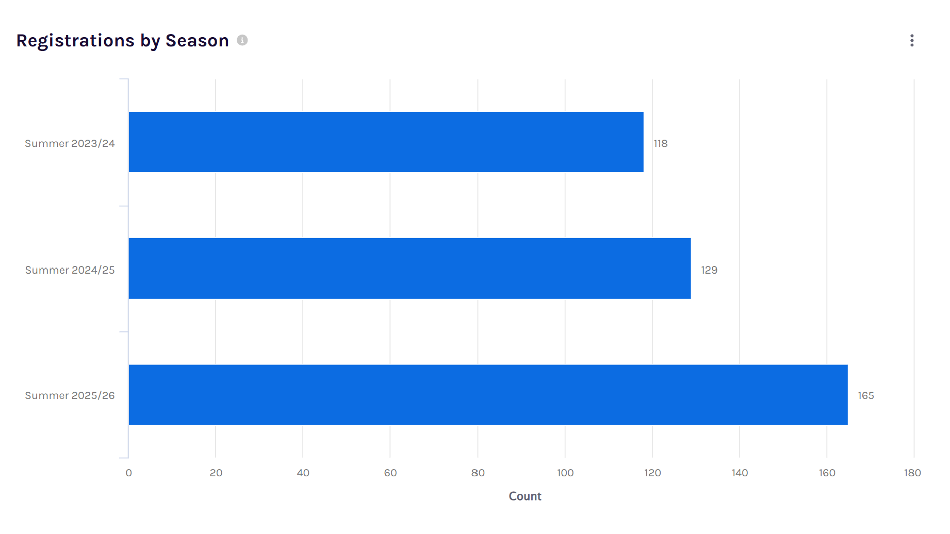
Blasters Growth
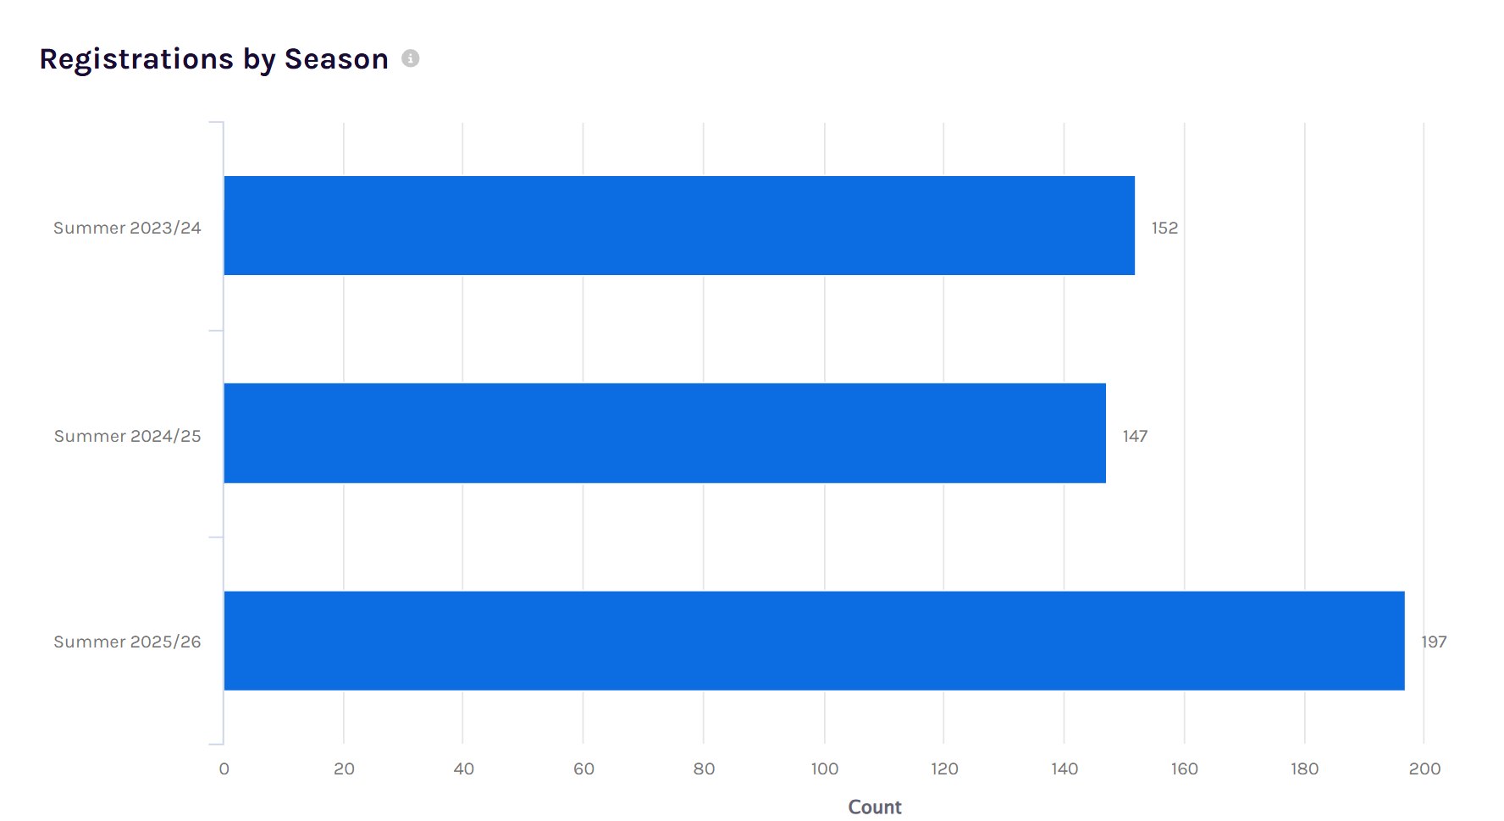

Junior Growth
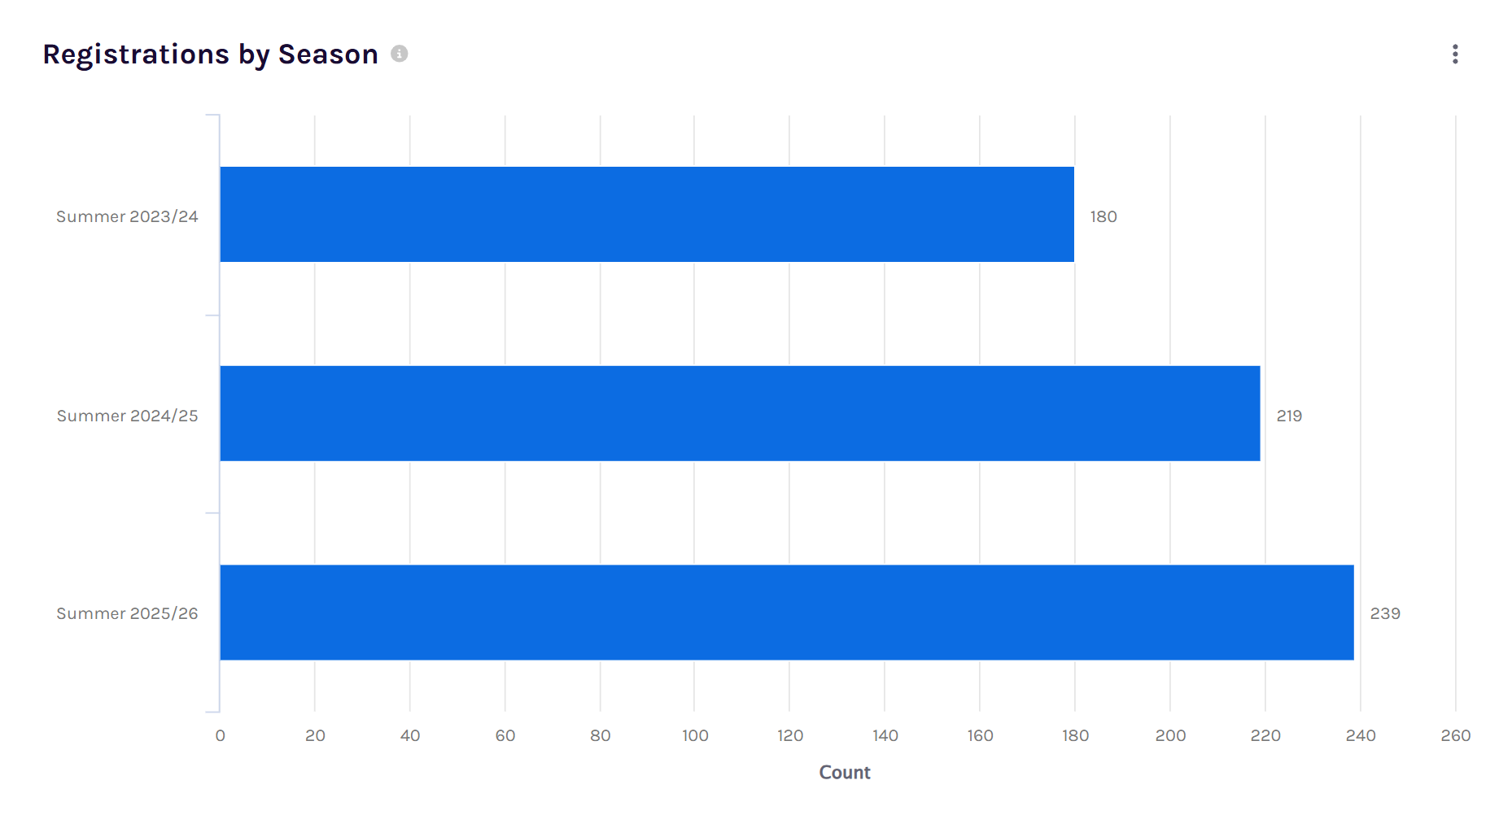
Senior Growth

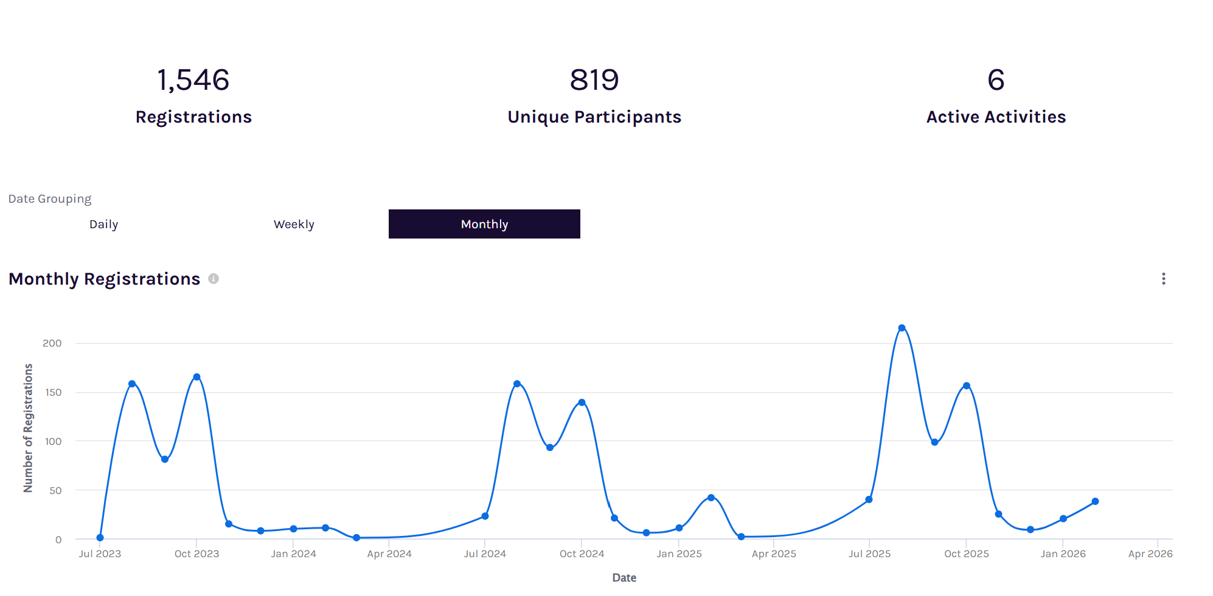

Registration Activity Overview
This dashboard provides an overview of participation activity across the club over the past several seasons. During this period, the club recorded 1,546 total registrations, representing 819 unique participants across 6 active programs or competitions. This indicates that many players participate in multiple formats or competitions throughout the season, reflecting strong engagement within the club.
The monthly registrations graph highlights a clear seasonal pattern in participation. Registrations typically begin to increase from July, peak between August and October, and then decline once competitions are underway. This aligns with the traditional cricket season registration period when teams are being formed and competitions commence.
The most notable peak occurs in August 2025, where registrations exceeded 200 in a single month, representing the highest recruitment period across the timeframe. Similar spikes are visible at the start of previous seasons, demonstrating a consistent annual cycle of player sign-ups.
Overall, the data reflects healthy participation levels and strong preseason recruitment, with the majority of players registering in the lead-up to each cricket season. This consistent seasonal engagement highlights the club’s ability to attract and retain players year after year.
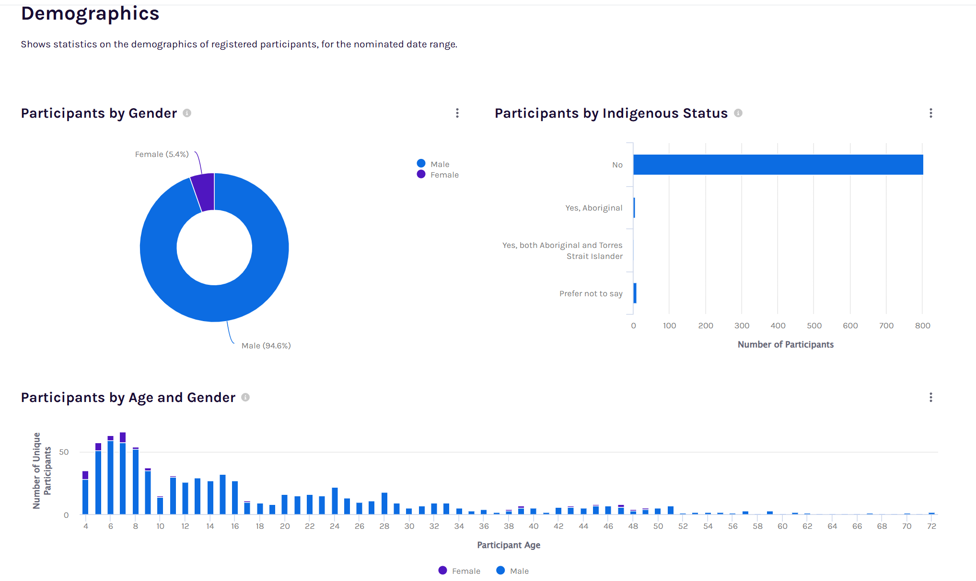

Participant Demographics Overview
This demographic snapshot provides insight into the composition of the club’s playing community across gender, age groups, and indigenous status.
The gender distribution shows that male participants currently represent the majority of players, with 775 males (94.6%) compared to 44 females (5.4%). While the club remains predominantly male, the presence of female participants highlights opportunities for continued growth in girls’ and women’s cricket programs, an area that is expanding rapidly across Australian cricket.
The age distribution chart demonstrates a strong concentration of players in the junior age groups between 5 and 16 years, reflecting the club’s strong junior development pathway. Participation gradually tapers through the late teenage years before increasing again in the adult categories, representing the club’s senior competition teams. The presence of participants across a wide age range—from young children through to players in their 60s and 70s—illustrates the club’s ability to provide cricket opportunities across all life stages.
The Indigenous status data indicates that the vast majority of participants identify as non-Indigenous, with a small number of participants identifying as Aboriginal or choosing not to disclose. While representation is currently limited, the club remains committed to promoting inclusive participation and community engagement across all backgrounds.
Overall, the demographics highlight a family-focused community club with a strong junior base and broad age participation, providing a clear pathway from entry-level cricket through to senior and veterans competition.
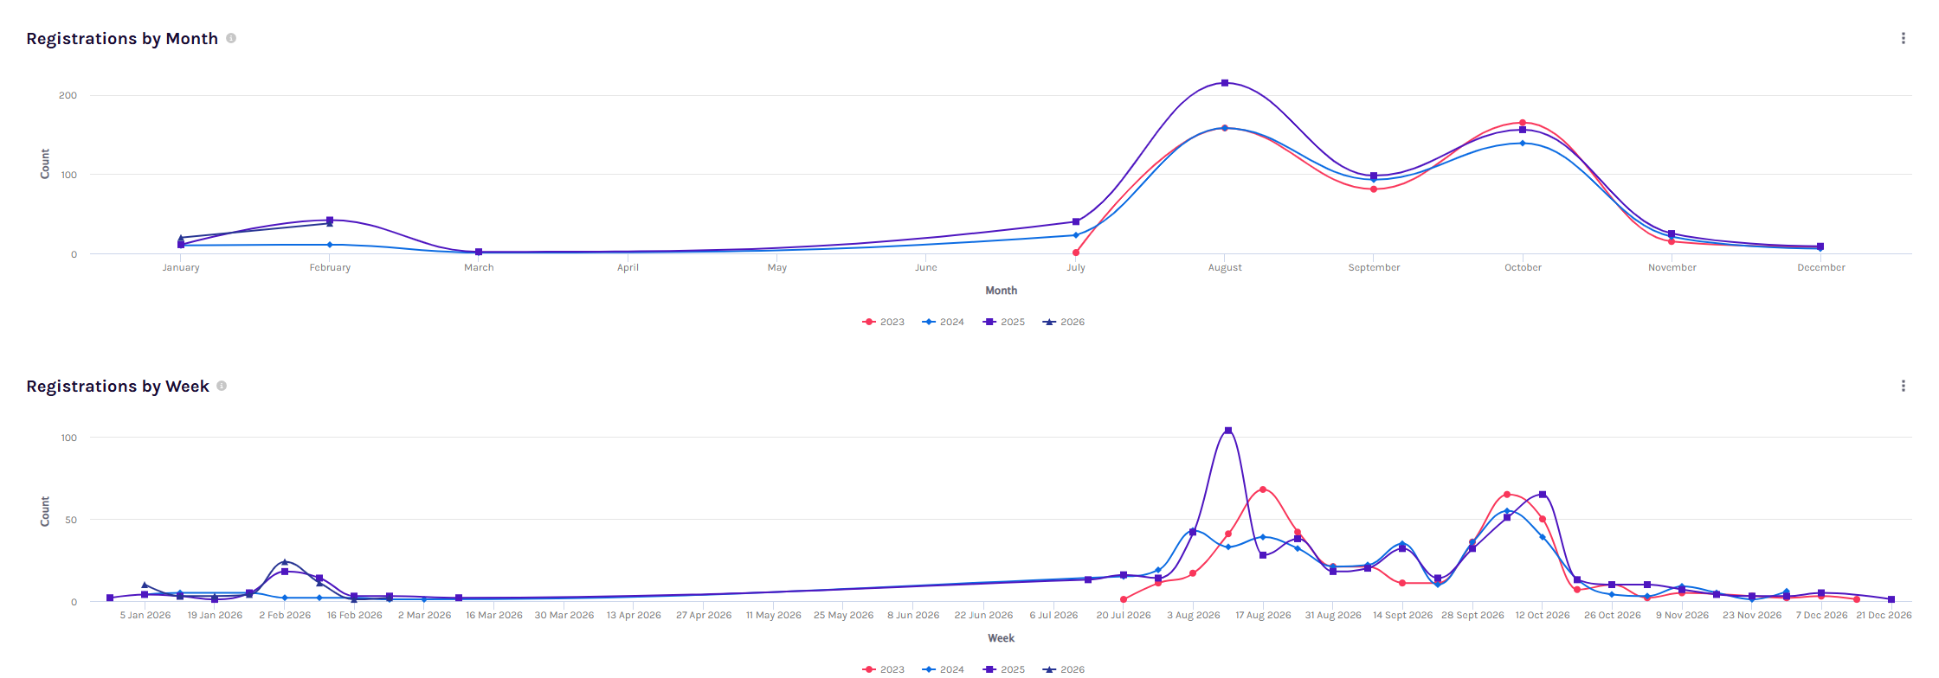

Registration Trends by Month and Week
This chart illustrates the seasonal pattern of player registrations across multiple years, showing both monthly and weekly registration activity.
The monthly data clearly highlights a consistent preseason registration period, with the majority of players registering between July and October each year. The largest spike typically occurs in August, when registrations peak as teams are finalised and competitions approach the start of the cricket season. A secondary increase is also visible in October, likely reflecting late registrations as competitions commence.
Outside of this period, registration activity remains relatively low, particularly between November and June, when most competitions are already underway and new registrations are minimal.
The weekly registration data provides a more detailed view, confirming that registrations tend to occur in concentrated bursts during key weeks of the preseason period. The largest weekly spike occurs in mid-August, where registrations exceed 100 in a single week, demonstrating the club’s most active recruitment period.
Overall, the data highlights a strong and predictable seasonal registration cycle, with the club successfully attracting the majority of its participants in the lead-up to each cricket season. This pattern reflects effective preseason engagement and provides clear insight into when recruitment and promotional activities are most impactful.
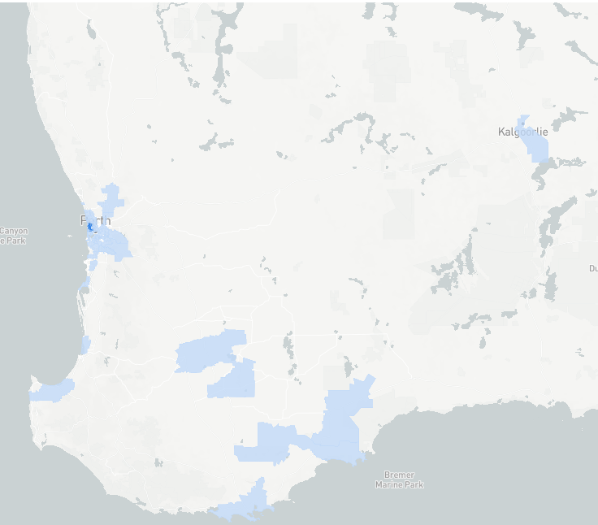
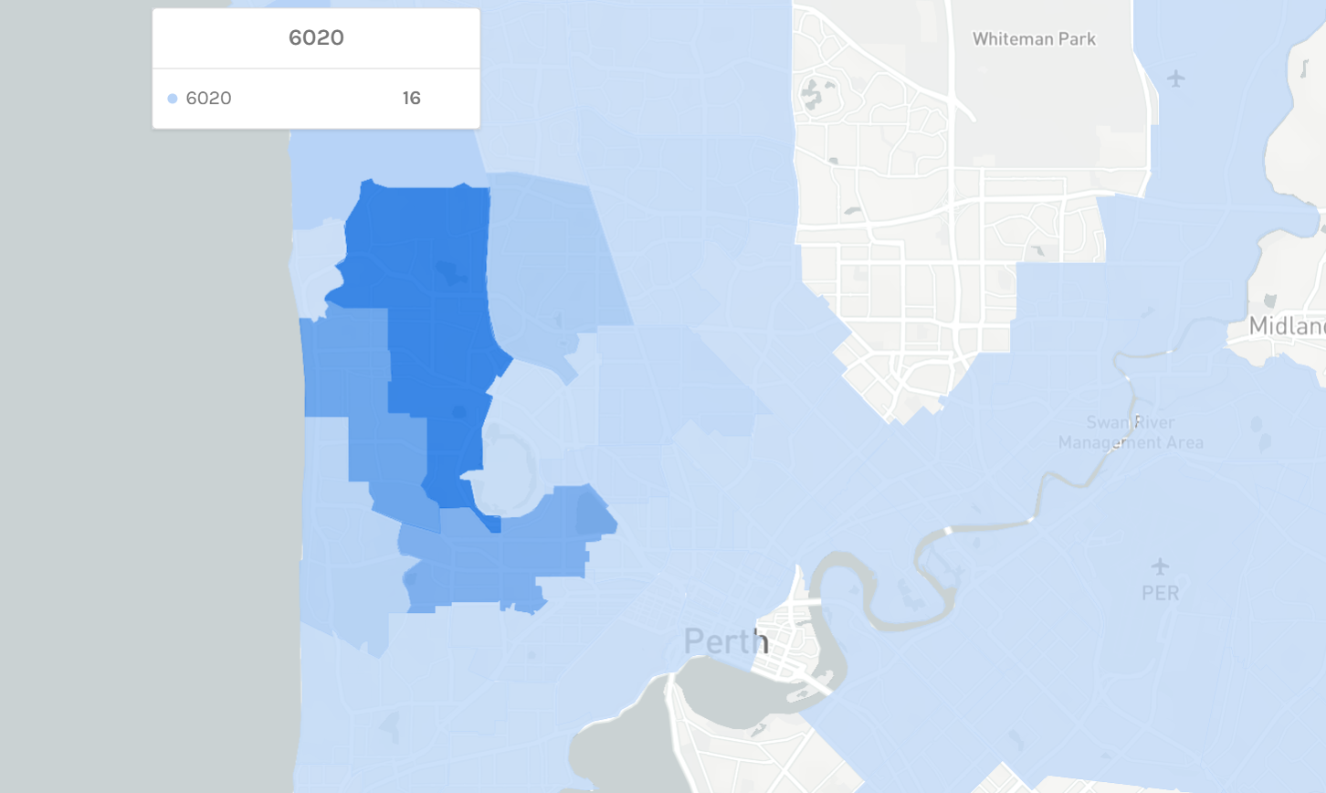

Geographic Distribution of Participants – Churchlands District Focus
The geographic data clearly highlights that the core player base of Subiaco Marist Cricket Club is centred within the Churchlands district and its surrounding western suburbs, reinforcing the club’s strong identity as a local community club serving this area.
The largest concentration of participants comes from Postcode 6018, which includes Churchlands, Doubleview, Gwelup, Innaloo, Karrinyup and Woodlands, accounting for 227 players. This postcode represents the single largest contributor to the club’s participation, demonstrating that the Churchlands catchment area forms the heart of the club’s community.
Additional strong participation comes from neighbouring western suburbs including:
- 6019 – Scarborough and Wembley Downs (148 participants)
- 6014 – Floreat, Wembley and Jolimont (124 participants)
- 6015 – City Beach (32 participants)
These suburbs surround the Churchlands district and collectively form the primary participation corridor of the club, all located within close proximity to the club’s home grounds at John Lucas Oval, Newman College.
The data highlights that Subiaco Marist Cricket Club serves as a central sporting hub for families within the Churchlands district, drawing players from nearby schools and residential communities. While some participation extends to other areas of Perth, the overwhelming majority of players come from the western suburbs surrounding Churchlands, confirming the club’s deep roots within this local community.
This strong geographic concentration reinforces the club’s role as a key grassroots sporting organisation within the Churchlands district, supporting junior development, family participation, and community sport across the region.
Thank you for taking the time for reading this document and if you have any enquiries please don’t hesitate to contact myself or the committee.
General Enquiries
subiacomarist.info@gmail.com
Website
www.subiacomaristcc.com.au
Location
John Lucas Oval, Newman College
Churchlands, Western Australia
Michael Spiteri
President /Life Member
M. 0401051489



