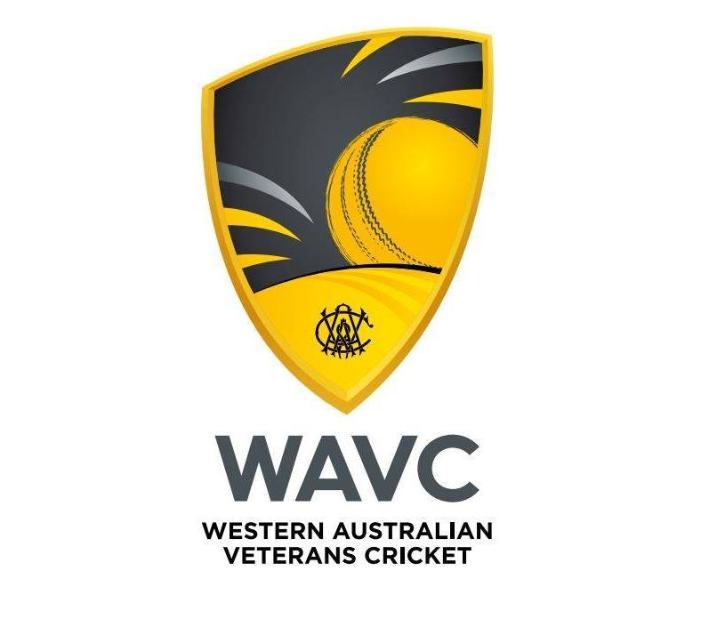

WAVC Focus Cricket League

Prospectus

The WA Veterans Cricket Association(WAVC) created an over 45’s Cricket Competition 5 years ago, for those male players of an older demographic and as an introduction to participating in the National over age carnivals. It brings together players from multiple teams, clubs and competitions to create teams that compete against similar aged players in a competitive but collegial competition, on higher level turf facilities.
Veterans Cricket is a rapidly growing sector of the cricket family, allowing past players to return or existing players to continue to compete against players of a similar demographic. WAVC started the Over 45’s competition 6 seasons ago with 4 teams, and last season grew to have 11 teams in Over 50’s spread over 2 divisions and geographically from the South-West(Bunbury/Harvey) to the Swan Valley and Joondalup in the North. We also had 6 teams play in an Over 60’s division for their second season and 7 teams in the Inaugural Over 40’s competition.
The Rules(attached) and playing conditions have been designed to maximise participation while hopefully reducing wear and tear on the participants, and reducing the time spent in the field.
What to do next?
Registrations of clubs for this season must close 5th of September 2025. If your club is interested in forming or hosting a team in the 2025/2026 season, you need to contact us immediately(Garry Edgar competitions@wavc.org.au). If you don’t think you will have sufficient players to fill a 12 or 13 player team, we recommend following in the footsteps of the existing teams and canvas support from eligible players at Clubs within your local area.

